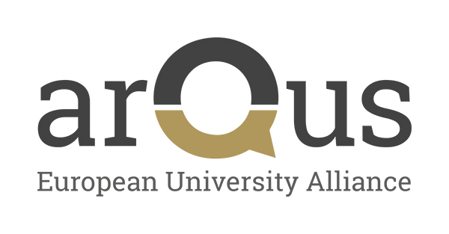
Letter of Intent
Twinning Collaboration Between Arqus Universities
under NAWA project on the European Alliances support
To Whom It May Concern,
On behalf of [University A] and [University B], members of the Arqus European University Alliance, we are pleased to express our mutual intention to collaborate on the implementation of a student exchange initiative under the "Twinning" initiative.
The purpose of this collaboration is to enhance academic and cultural exchange, foster international cooperation, and strengthen ties within the Arqus community. The Twinning initiative will enable students from both universities to engage in meaningful learning experiences, enriching their academic and personal development.
This agreement will be in effect during the period from [start date] to [end date]. The specifics of the Twinning initiative, including the number of participants, duration of exchanges, and program details, will be determined jointly by both institutions.
Both [University A] and [University B] are committed to providing the necessary support to ensure the success of this initiative and to create a valuable experience for all participants.
We look forward to finalizing the details of this collaboration and to a fruitful partnership.
Sincerely,
[Name]
[Title]
[University A]
[Name]
[Title]
[University B]

