3rd International School

of Karst and Speleology

Summer School 2023
Polish Jurassic Highland

University of Wrocław

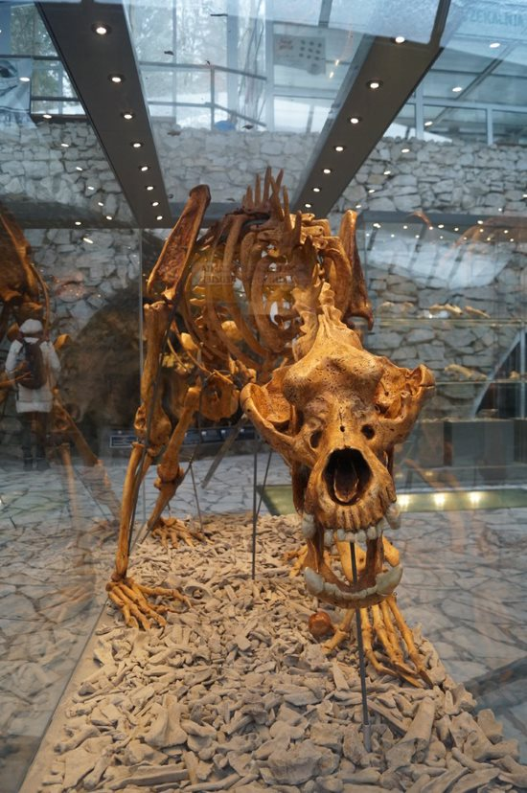
3rd International School of Karst and Speleology
Summer School 2023

Dates: 16-23.07.2023Location: Siedlec near Złoty Potok (Kraków-Częstochowa Upland)
Language: English, Polish
Target Group: international students and young scientists (age 18 to 35)
Total number of participants (max): 24
Application Deadline: April 30, 2023

In order to apply for the Summer School, all interested are obliged to submit a 500-word abstract regarding one of the following topics: karst, archeology, paleontology, or drift geology in your home country. The selection of students will be carried out by the organizers.

All applications must be sent by the 30th of April to the following email address: paleosummerschool@uwr.edu.pl
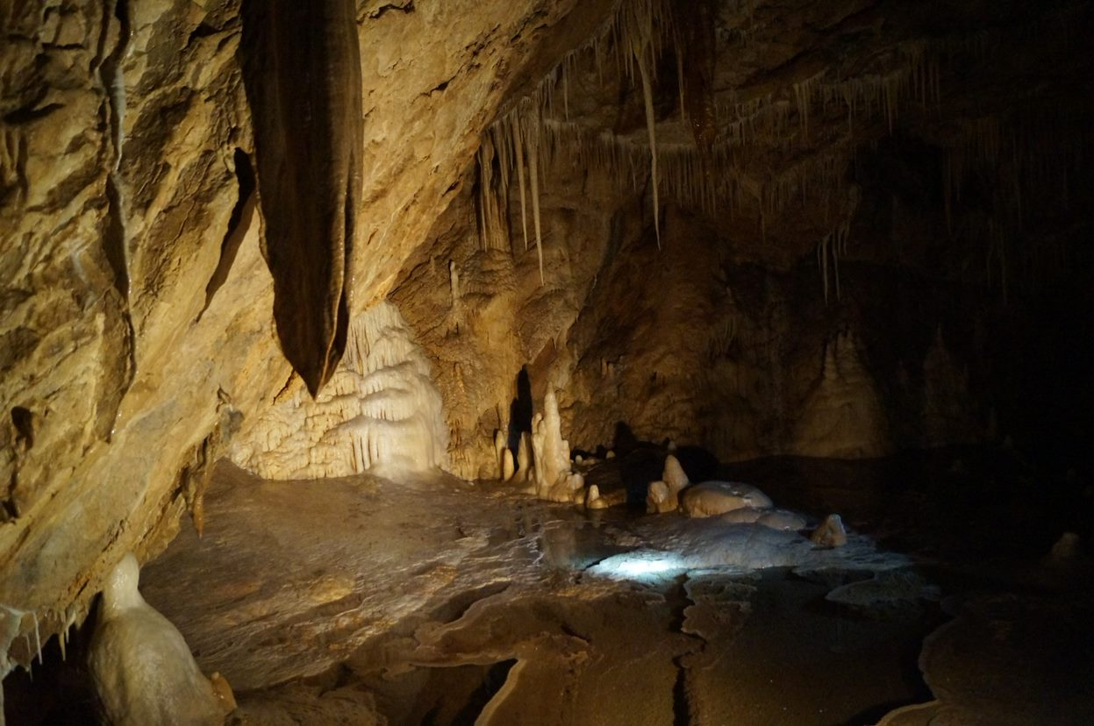

Schedule

DATE | LOCATION | PROGRAMme
16.07.2023 | Wrocław | Arrival of participants in Wroclaw
17.07.2023 | Wrocław | Visit to the University of Wroclaw International Office. Transfer from Wroclaw to Siedlce.
18.07.2023 | Siedlec | Geology and geomorphology: Lectures + Practical classes
19.07.2023 | Siedlec | Geology and geomorphology: Practical classes
20.07.2023 | Siedlec | Geology and geomorphology: Practical classes
21.07.2023 | Field trip I | Upper Paleolithic site of mammoth hunters Krakow Spadzista street.  Ojcow National Park visit to Ciemna Cave and Łokietka Cave
22.07.2023 | Field trip II | Wodąca Valley visit to Biśnik Cave and Zegarowe Rocks with Zegar Cave.  Mount Zborów visit to the Głęboka Cave.  Karst springs in Podlesice  Return of participants to Wroclaw.
23.07.2023 | Wrocław | Return of participants to home

PROGRAMME
Paleozoology and archaeology
Prof. Krzysztof Stefaniak, Prof. Adrian Marciszak, PhD Urszula Ratajczak-Skrzatek, PhD Katarzyna Zarzecka- Szubińska - Department of Palaeozoology, University of Wroclaw
- Methodology of paleontological and archaeological research– Lecture and practical classes

- Methods of acquiring, documenting, cataloguing and developing collections– Practical classes

- Evolution of the fossil fauna of Poland in the Neogene and Quaternary– – Lecture and practical classes

- Stages of human settlement of the Polish area from the Paleolithic to historical times in karst areas– – Lecture and practical classes

Geology and geomorphology
PhD Artur Sobczyk – Institute of Geological Sciences, University of Wroclaw
- Karst, caves and speleology: an introduction – Lecture

- Methodology of conducting research related to geomorphology and geology of caves and karst areas – Practical classes

- Geological mapping with the use of spatial data – Practical classes

- Application of ground penetrating radar (GPR) in karst research – Practical classes

PhD Hab. Marek Kasprzak – Institute of Geography and Regional Development, University of Wroclaw
- Introduction to SfM point clouds derived photogrammetry and LiDAR numerical terrain model – Lecture

- Geomorphological mapping with the use of spatial data – Practical classes

- Creation and management of data in a GIS environment – Practical classes

- Application of electrical resistivity tomography (ERT) in karst research – Practical classes

Short description of the school: During the Summer School, archaeological and paleontological excavations will be conducted in Reniferowa Cave, accompanied by geomorphological and geological studies of cave sediments. In addition, excursions will be organized to show participants selected archaeological, paleontological and geomorphological sites in Kraków - Częstochowa Upland.

Accommodation: Participants in Wroclaw will be accommodated in a dormitory. During the practical part, participants will be accommodated Siedlce in the Youth Hostel.
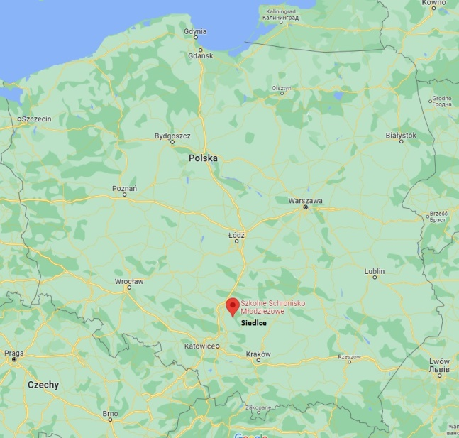
Fig. 1 Place of accommodation of participants.

The organizers reserve the right to change the program.

