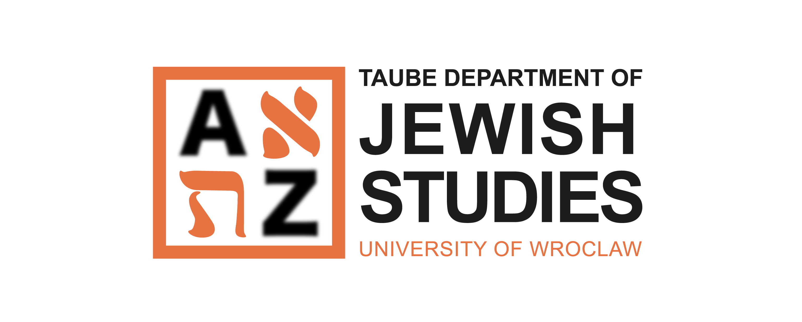

INTERNATIONAL

MA PROGRAMME

IN EASTERN EUROPEAN

JEWISH STUDIES

Curriculum

The course load is built around intensive master classes focused on three core research areas: 1) Hasidism, 2) Yiddish culture, and 3) the social and political history of Jews in East Europe. Each master class is accompanied by a relevant lecture. Master classes and their accompanying lectures are offered in two of the three areas mentioned above in each teaching cycle. Students are required to complete two elective master classes in the first two semesters of the programme. All accompanying lectures are obligatory. In total, each student completes five lecture courses covering all three of the core research areas.
Year I, First Semester

Course/Module | O/ E*** | Type of Course** |  |  |  |  | Number  of Hours | Assessment Method | ECTS  Points
 |  | L | C | S | T | Lc
Monographic Lecture 1 | O | 30 |  |  |  |  | 30 | E | 3
Monographic Lecture 2 | O | 30 |  |  |  |  | 30 | E | 3
Two of these three lectures will be offered in this teaching cycle: Social and Cultural History of Hasidism, Modern Yiddish Literature in an East European Context, Jewish Modernity in Poland from the Mid-19th Century to the Holocaust
MA Seminar on Methods  and Research Trends  in Jewish Studies I | O |  |  | 30 |  |  | 30 | GC | 5
Applied Jewish Heritage | O |  |  |  | 30 |  | 30 | GC | 3
Polish language  for international students | O |  |  |  |  | 30 | 30 | GC | 0
Foreign language | O |  |  |  |  | 30 | 30 | GC | 0
Health and Safety training course online | O |  | 4 |  |  |  | 4 |  | 0
Elective Master Classes  Two of these three master classes will be offered  in this teaching cycle: | E |  |  |  | 30 |  | 30 | GC | 7
Social and Cultural History
of Hasidism – master class
Modern Yiddish Literature in the Eastern European Context – master class
Jewish Modernity in Poland from the Mid-19th Century
to the Holocaust
Elective Jewish language beginners level*: | E |  |  |  | 60 |  | 60 | GC | 5
Hebrew 1
Yiddish 1
Elective Jewish language advanced level*: | E |  |  |  | 60 |  | 60 | GC | 5
Hebrew 2
Yiddish 2
Total number of ECTS credits in the first semester: 31
Total number of class hours: 304 (334 for students enrolled in Polish language classes)
Year I, Second Semester

Course/Module | O/ E*** | Type of Course** |  |  |  |  | Number  of Hours | Assessment Method | ECTS  Points
 |  | L | C | S | T | Lc
Monographic Lecture 3 | O | 30 |  |  |  |  | 30 | E | 3
Monographic Lecture 4 | O | 30 |  |  |  |  | 30 | E | 3
Two of these three lectures will be offered in this teaching cycle: Hasidism as Jewish Mysticism, Theories of Yiddish Culture, Social History of Jewish-Christian Relations in Polish Lands from the Mid-19th Century to the Holocaust
MA Seminar on Methods  and Research Trends  in Jewish Studies II | O |  |  | 30 |  |  | 30 | GC | 5
Applied Heritage Field Seminar | O |  |  |  | 30 |  | 30 | GC | 5
Polish language  for international students | O |  |  |  |  | 30 | 30 | E | 5
Foreign language | O |  |  |  |  | 30 | 30 | E | 4
Elective Master Classes  Two of these three master classes will be offered  in this teaching cycle: | E |  |  |  | 30 |  | 30 | GC | 7
Hasidism as Jewish Mysticism
Theories of Yiddish Culture
Social History of Jewish-Christian Relations in Polish Lands from the Mid-19th Century to the Holocaust
Elective Jewish language beginners level*: | E |  |  |  | 60 |  | 60 | GC | 5
Hebrew 1 - continuation
Yiddish 1 - continuation
Elective Jewish language advanced level*: | E |  |  |  | 60 |  | 60 | GC | 5
Hebrew 2 - continuation
Yiddish 2 - continuation
Total number of ECTS credits: 37 (42 for students enrolled in Polish language classes)
Total number of class hours: 300 (330 for students enrolled in Polish language classes)

Year II, First Semester

Course/Module | O/ E*** | Type of Course** |  |  |  |  | Number  of Hours | Assessment Method | ECTS  Points
 |  | L | C | S | T | Lc
Monographic Lecture 5 | O | 30 |  |  |  |  | 30 | E | 3
One of these three lectures will be offered in this teaching cycle: Social and Cultural History of Hasidism, Modern Yiddish Literature in the Eastern European Context, Jewish Modernity in Poland from the Mid-19th Century to the Holocaust
MA Seminar  and Thesis Writing | O |  |  | 30 |  |  | 30 | GC | 23
Elective Translation Course: | E |  |  |  | 30 |  | 30 | GC | 4
Translation Course – Hebrew
Translation Course – Yiddish
Total number of ECTS credits: 30
Total number of class hours: 90

Subjects: obligatory – O / elective – E
* Students are required to study both Jewish languages (Hebrew and Yiddish) at the level chosen by students from the courses offered by the Department.

Additional information:
Students are required to pass a mandatory Health and Safety training course online during the first semester of Year I.

KEY
Types of courses: Assessment methods:
L – lecture E – exam
C – class GC – graded credit
S – seminar
T – tutorial
Lc – language classes

