Academic Year 2023/2024

Year I, First Semester

Course/Module | O/ E*** | Type of Course** |  |  |  |  | Number  of Hours | Assessment Method | ECTS  Points
 |  | L | C | S | T | Lc
Monographic Lecture 1.  Social and Cultural History of Hasidism | O | 30 |  |  |  |  | 30 | E | 3
Monographic Lecture 2. Modern Yiddish Literature  in an East European Context | O | 30 |  |  |  |  | 30 | E | 3
MA Seminar on Methods and Research Trends  in Jewish Studies I | O |  |  | 30 |  |  | 30 | GC | 5
Applied Jewish Heritage | O |  |  |  | 30 |  | 30 | GC | 3
Polish language for international students | O |  |  |  |  | 30 | 30 | GC | 0
Foreign language | O |  |  |  |  | 30 | 30 | GC | 0
Health and Safety training course online | O |  | 4 |  |  |  | 4 |  | 0
Elective Master Class: | E |  |  |  | 30 |  | 30 | GC | 7
Social and Cultural History of Hasidism – master class
Modern Yiddish Literature in the Eastern European Context – master class
Elective Hebrew or Yiddish language beginners level*: | E |  |  |  | 60 |  | 60 | GC | 5
Hebrew 1
Yiddish 1
Elective Hebrew or Yiddish language advanced level*: | E |  |  |  | 60 |  | 60 | GC | 5
Hebrew 2
Yiddish 2
Total number of ECTS credits in the first semester: 31
Total number of class hours: 304 (334 for students enrolled in Polish language classes)

Year I, Second Semester

Course/Module | O/ E*** | Type of Course** |  |  |  |  | Number  of Hours | Assessment Method | ECTS  Points
 |  | L | C | S | T | Lc
Monographic Lecture 3. Hasidism as Jewish Mysticism | O | 30 |  |  |  |  | 30 | E | 3
Monographic Lecture 4. Theories of Yiddish Culture | O | 30 |  |  |  |  | 30 | E | 3
MA Seminar on Methods  and Research Trends  in Jewish Studies II | O |  |  | 30 |  |  | 30 | GC | 5
Applied Heritage Field Seminar | O |  |  |  | 30 |  | 30 | GC | 5
Polish language  for international students | O |  |  |  |  | 30 | 30 | E | 5
Foreign language | O |  |  |  |  | 30 | 30 | E | 4
Elective Master Class: | E |  |  |  | 30 |  | 30 | GC | 7
Hasidism as Jewish Mysticism – master class
Theories of Yiddish Culture – master class
Elective Hebrew or Yiddish language beginners level*: | E |  |  |  | 60 |  | 60 | GC | 5
Hebrew 1 - continuation
Yiddish 1 - continuation
Elective Hebrew or Yiddish language advanced level*: | E |  |  |  | 60 |  | 60 | GC | 5
Hebrew 2 - continuation
Yiddish 2 - continuation
Monographic Lecture 3. Hasidism as Jewish Mysticism | O | 30 |  |  |  |  | 30 | E | 3
Total number of ECTS credits: 37 (42 for students enrolled in Polish language classes)
Total number of class hours: 300 (330 for students enrolled in Polish language classes)

Year II, First Semester

Course/Module | O/ E*** | Type of Course** |  |  |  |  | Number  of Hours | Assessment Method | ECTS  Points
 |  | L | C | S | T | Lc
Monographic Lecture 5.  Jewish Modernity in Poland  from the Mid-19th Century to the Holocaust | O | 30 |  |  |  |  | 30 | E | 3
One of these three lectures will be offered in this teaching cycle: Social and Cultural History of Hasidism, Modern Yiddish Literature in the Eastern European Context, Jewish Modernity in Poland from the Mid-19th Century to the Holocaust
MA Seminar  and Thesis Writing | O |  |  | 30 |  |  | 30 | GC | 23
Elective Translation Course: | E |  |  |  | 30 |  | 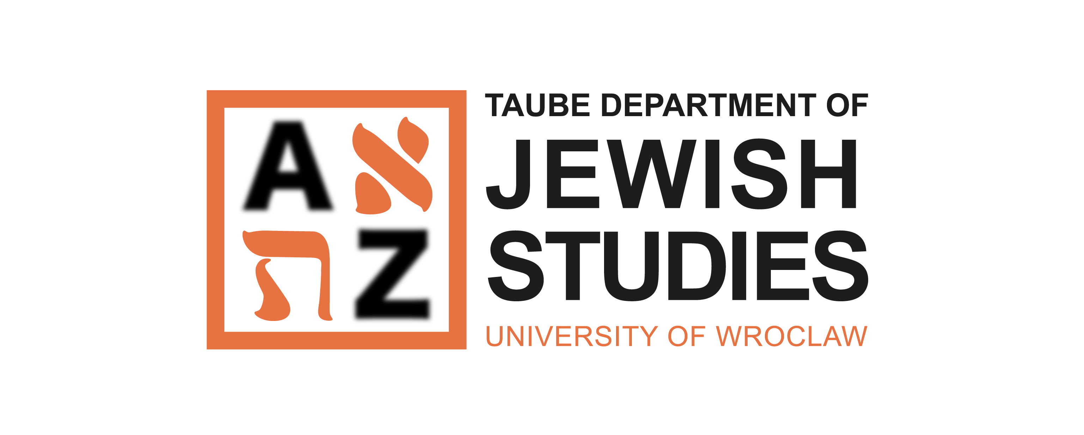  30 | GC | 4
Translation Course – Hebrew
Translation Course – Yiddish
Total number of ECTS credits: 30
Total number of class hours: 90

Subjects: obligatory – O / elective – E
* Students are required to study both Jewish languages (Hebrew and Yiddish) at the level chosen by students from the courses offered by the Department.

Additional information:
Students are required to pass a mandatory Health and Safety training course online during the first semester of Year I.

KEY
Types of courses: Assessment methods:
L – lecture E – exam
C – class GC – graded credit
S – seminar
T – tutorial
Lc – language classes

